RiverBird International Trading Co., Ltd.
Farouk CHI&Instyler Hair Straightener Quotation Sheet
(USA,Canada,Mexico)
www.riverbirdtrading.com

www.riverbirdtrade.com |  |  |  |  | Term of quoted price validity:Dec,31,2011
Supplier： | RiverBird International Trading |  | Tel: |  | 8618965658099 |  |  |  |  | Fax： |  |  |  | 86-0595-22751075
Main Prodcuts： | GHD&Farouk CHI&Instyler Hair Straightener&T3 Hair Dryer&Babyliss |  | E-mail： |  | riverbirdtrade@hotmail.com |  |  |  |  | Contact： |  |  |  | Amanda
Model | Photo/Image | Item No | Sample Price |  | MOQ 12PCS |  | MOQ 24PCS |  | MOQ 40PCS |  | MOQ 60PCS |  |  |  | MOQ 100PCS |  | >100PCS
CHI Tribal Zebra Collection | 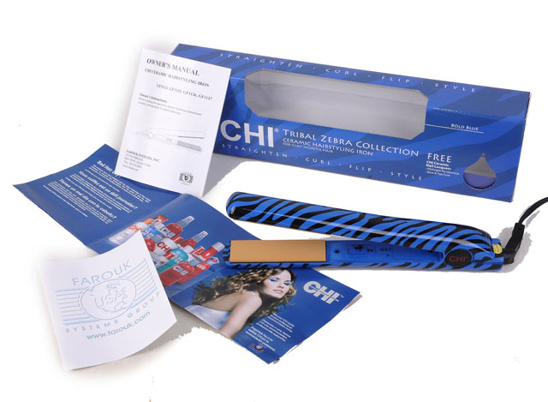 | C22 | 20usd |  | 20usd |  | 19.5usd |  | 19usd |  | 18.5usd |  |  |  | 18usd |  | N
CHI Tribal Zebra Collection | 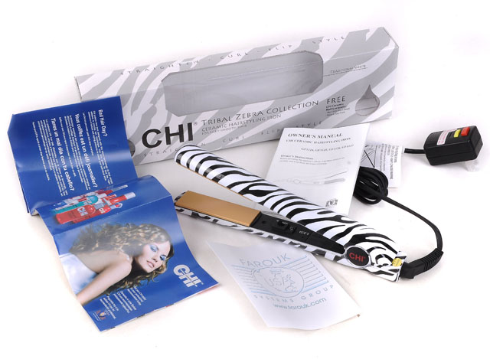 | C23 | 20usd |  | 20usd |  | 19.5usd |  | 19usd |  | 18.5usd |  |  |  | 18usd |  | N
CHI Tribal Zebra Collection | 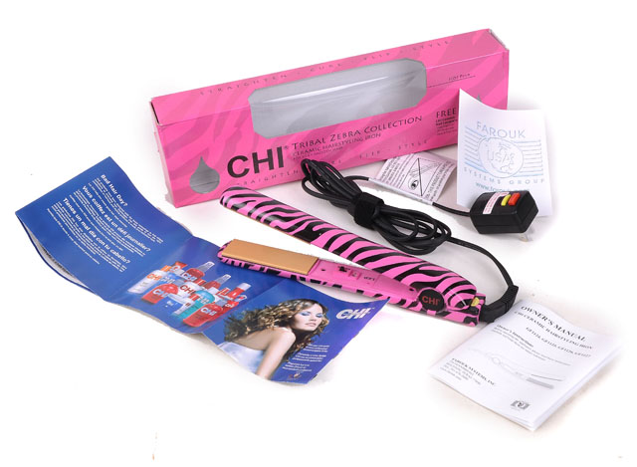 | C24 | 20usd |  | 20usd |  | 19.5usd |  | 19usd |  | 18.5usd |  |  |  | 18usd |  | N
CHI Earth Collection | 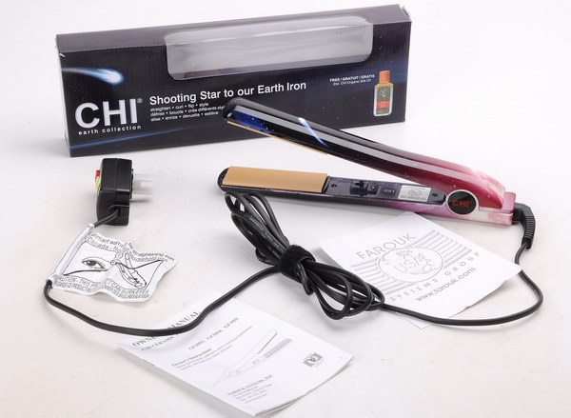 | C17 | 19usd |  | 19usd |  | 18.5usd |  | 18usd |  | 17.5usd |  |  |  | 17usd |  | N
CHI Gitar Collection New Limited Edition Blue | 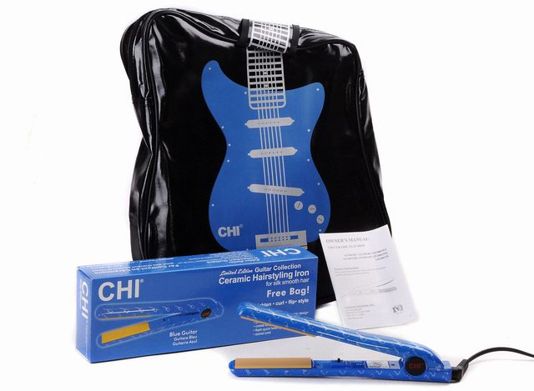 | C18 | 22usd |  | 22usd |  | 21.5usd |  | 21usd |  | 20.5usd |  |  |  | 20usd |  | N
CHI Gitar Collection New Limited Edition Red | 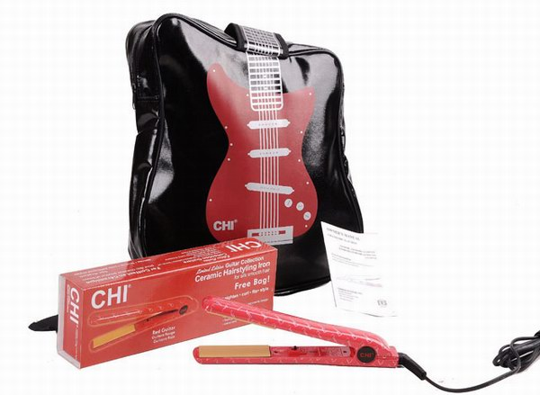 | C19 | 22usd |  | 22usd |  | 21.5usd |  | 21usd |  | 20.5usd |  |  |  | 20usd |  | N
CHI Gitar Collection New Limited Edition Purple | 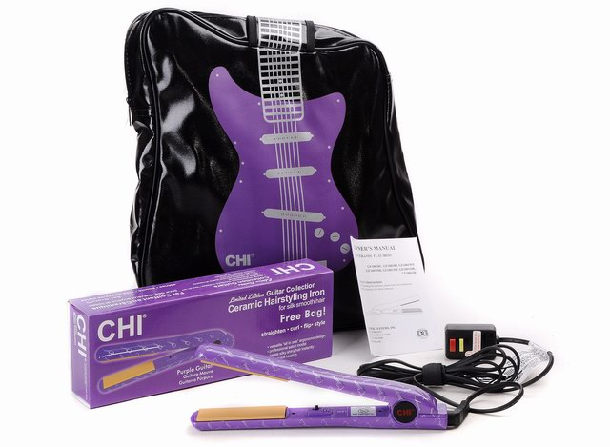 | C20 | 22usd |  | 22usd |  | 21.5usd |  | 21usd |  | 20.5usd |  |  |  | 20usd |  | N
CHI Wet-Dry Cermic | 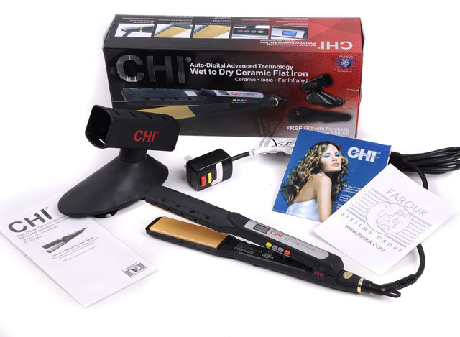 | C21 | 26usd |  | 26usd |  | 25.5usd |  | 25usd |  | 24.5usd |  |  |  | 24usd |  | N
Babyliss Professional Slim Straightener | 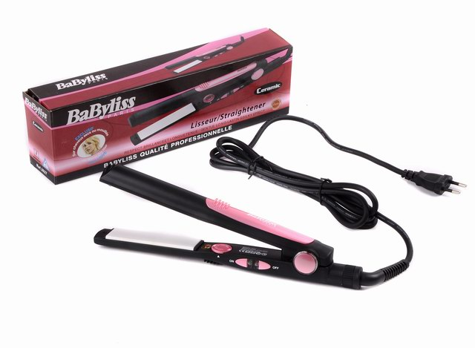 | B03 | 20usd |  | 20usd |  | 19.5usd |  | 19usd |  | 18.5usd |  |  |  | 18usd |  | N
Remington | 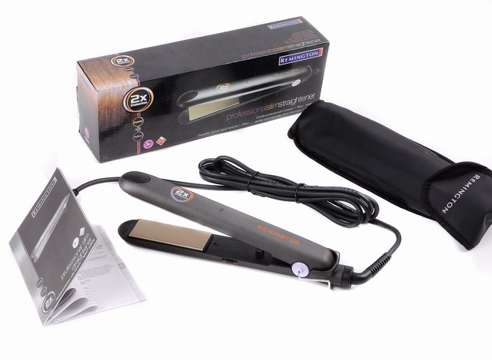 | R1 | 20usd |  | 20usd |  | 19.5usd |  | 19usd |  | 18.5usd |  |  |  | 18usd |  | N
CHI Black(Hot Model) | 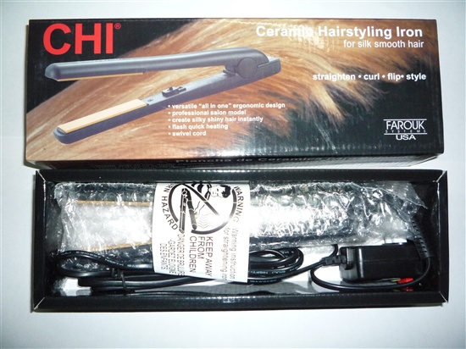 | C01 | 11.5usd |  | 11.5usd |  | 11usd |  | 10.5usd |  | 10usd |  |  |  | 9.5usd |  | Negotiation
CHI Pink Limited Edition | 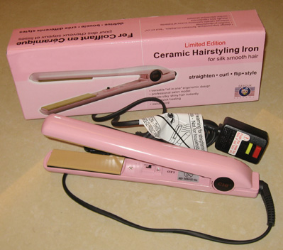 | C02 | 12.5usd |  | 12.5usd |  | 12usd |  | 11.5usd |  | 11usd |  |  |  | 10.5usd |  | N
CHI Pink Dazzle with a bag(Hot) | 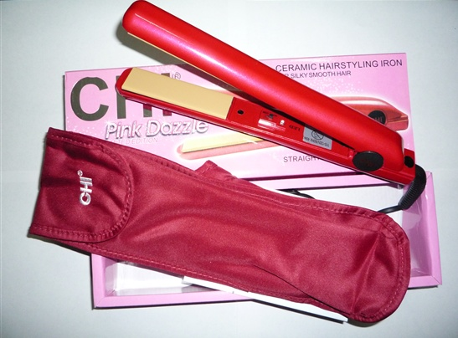 | C03 | 13.5usd |  | 13.5usd |  | 13usd |  | 12.5usd |  |  | 12usd |  |  | 11.5usd |  | N
CHI Blue Nano | 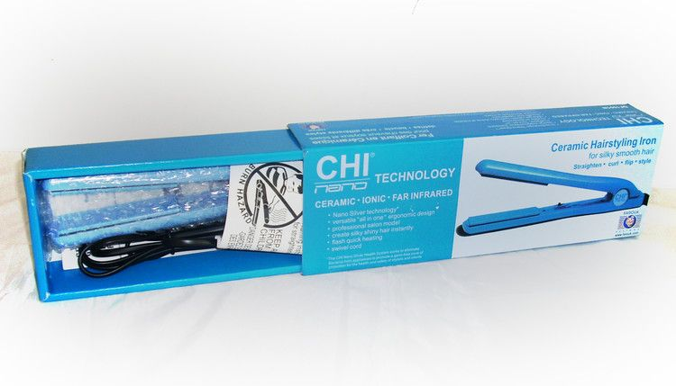 | C04 | 12.5usd |  | 12.5usd |  | 12usd |  | 11.5usd |  |  | 11usd |  |  | 10.5usd |  | N
CHI Pink Camo(Hot) | 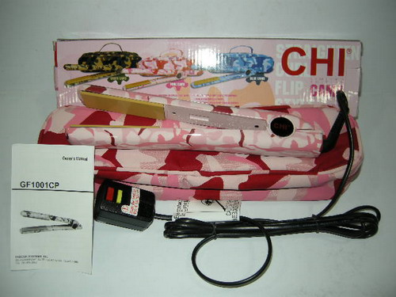 | C05 | 14.5usd |  | 14.5usd |  | 14usd |  | 13.5usd |  |  | 13usd |  |  | 12.5usd |  | N
CHI Blue Camo | 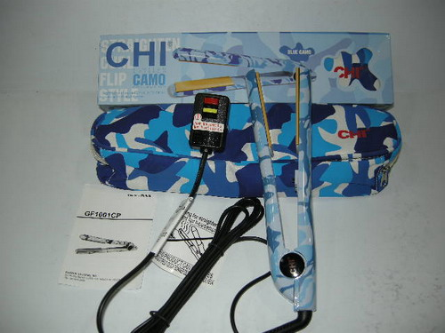 | C06 | 14.5usd |  | 14.5usd |  | 14usd |  | 13.5usd |  |  | 13usd |  |  | 12.5usd |  | N
CHI Green Camo | 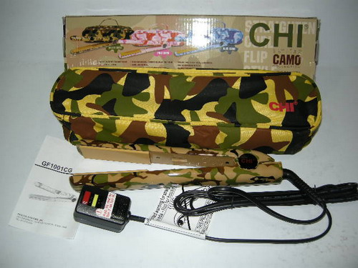 | C07 | 14.5usd |  | 14.5usd |  | 14usd |  | 13.5usd |  |  | 13usd |  |  | 12.5usd |  | N
CHI Wide Turbo 2inch (Hot) | 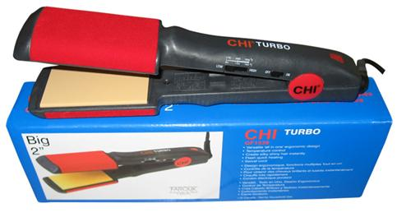 | C08 | 18.5usd |  | 18.5usd |  | 18usd |  | 17usd |  |  | 16.5usd |  |  | 16usd |  | N
CHI Digital Blue Nano(NEW Arrival) | 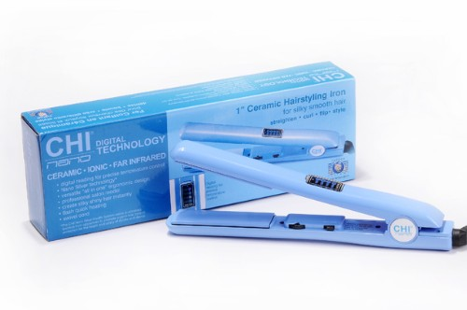 | C09 | 20.5usd |  | 20.5usd |  | 20usd |  | 19.5usd |  |  | 19usd |  |  | 23usd |  | N
CHI Skull Mania Black with a watch(New Arrival) | 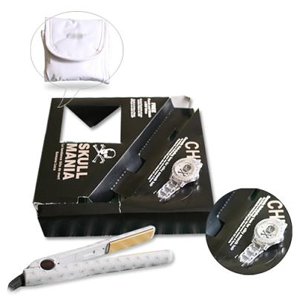 | C10 | 23usd |  | 23usd |  | 22.5usd |  | 22usd |  |  | 21.5usd |  |  | 21usd |  | N
CHI Skull Mania white with a watch(NEW Arrival) | 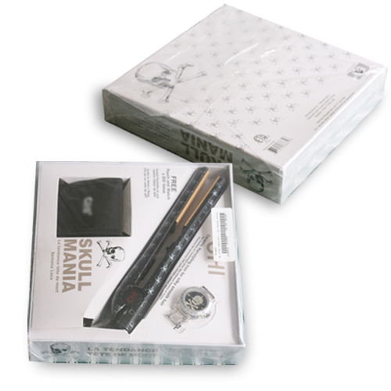 | C11 | 23usd |  | 23usd |  | 22.5usd |  | 22usd |  |  | 21.5usd |  |  | 21usd |  | N
CHI WEE(New Arrival) | 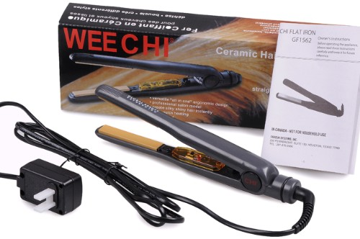 | C12 | 16.5usd |  | 16.5usd |  | 16usd |  | 15.5usd |  |  | 15usd |  |  | 14.5usd |  | N
CHI Wide Turbo 1'inch | 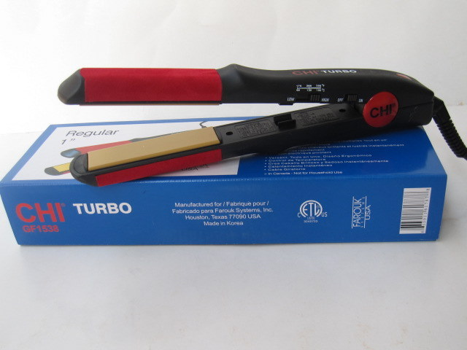 | C13 | 18.5usd |  | 18.5usd |  | 18usd |  | 17.5usd |  |  | 17usd |  |  | 16.5usd |  | N
T3 Evolution Hair Dryer(NEW&HOT) | 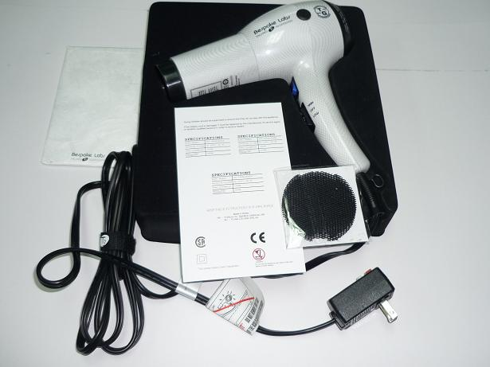 | T01 | 28.5usd |  | 28.5usd |  | 28usd |  | 27.5usd |  |  | 27usd |  |  | 26.5usd |  | N
Instyler As Seen On Tv(Hot),brown Packing | 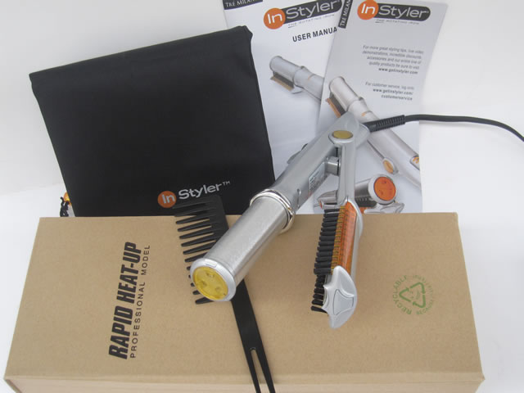 | I01 | 19usd |  | 19usd |  | 18.5usd |  | 18usd |  |  | 17.5usd |  |  | 17usd |  | N
Instyler As Seen On TV,colored packing | 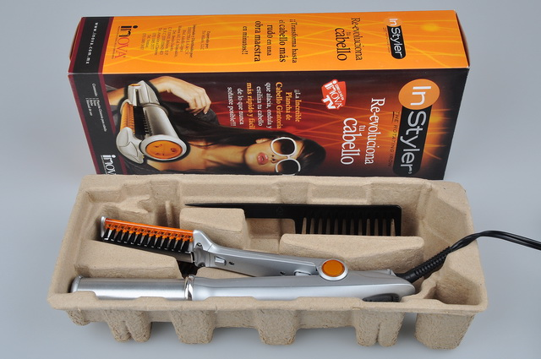 | I02 | 19.5usd |  | 19.5usd |  | 19usd |  | 18.5usd |  |  | 18usd |  |  | 17.5usd |  | N
Instyler Digital(NEW&HOT),pink packing | 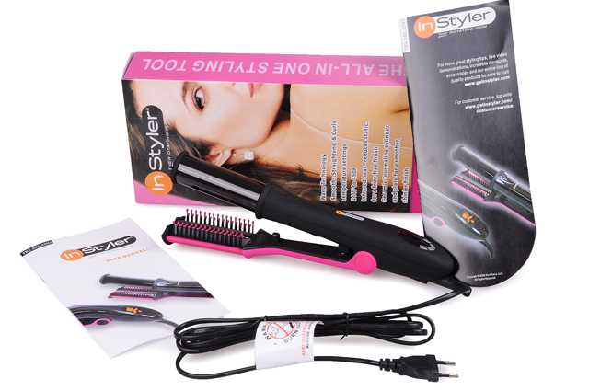 | I03 | 26usd |  | 26usd |  | 25.5usd |  | 25usd |  |  | 24.5usd |  |  | 24usd |  | N
Babyliss pro 230 radiance  (USA,UK,EU,AU Plug) | 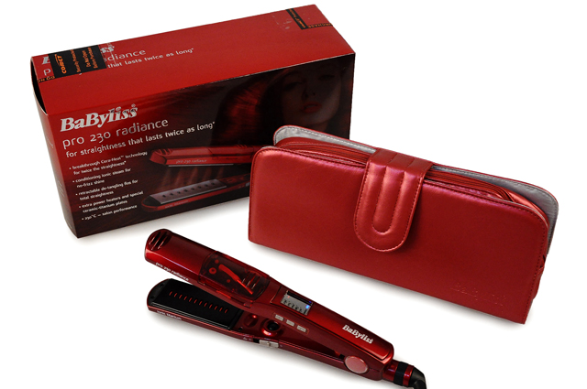 | B01 | 29.5usd |  | 29.5usd |  | 29usd |  | 28.5usd |  |  | 28usd |  |  | 27.5usd |  | N
CHI Digital Black | 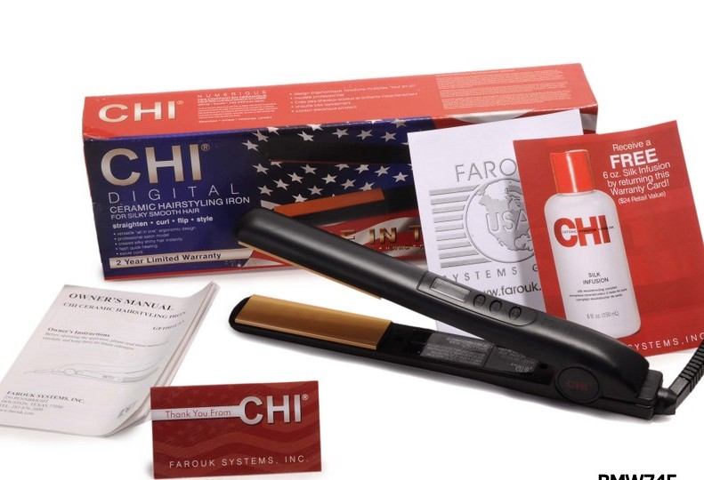 | C14 | 21usd |  | 21usd |  | 20.5usd |  | 20usd |  |  | 19.5usd |  |  | 19usd |  | N
CHI NEW Black | 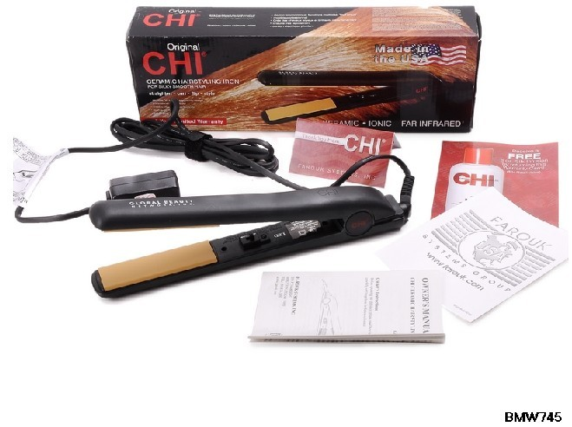 | C15 | 15usd |  | 15usd |  | 14.5usd |  | 14usd |  |  | 13.5usd |  |  | 13usd |  | N
New Blue Babyliss(USA,UK,AU,EU Plug) | 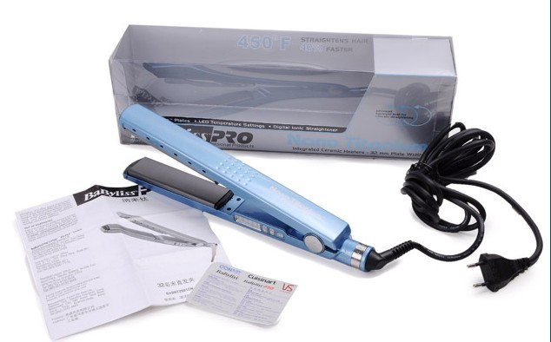 | B02 | 29.5usd |  | 29.5usd |  | 29usd |  | 28.5usd |  |  | 28usd |  |  | 27.5usd |  | N
Babyliss Brown | 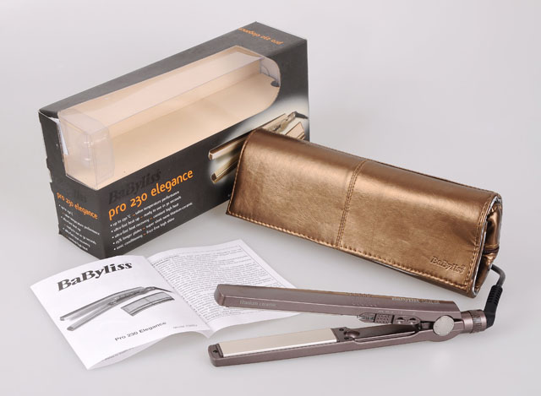 | B4 | 25usd |  | 25usd |  | 24.5usd |  | 24usd |  |  | 23.5usd |  |  | 23usd |  | N
CHI Pro Hair Dryer | 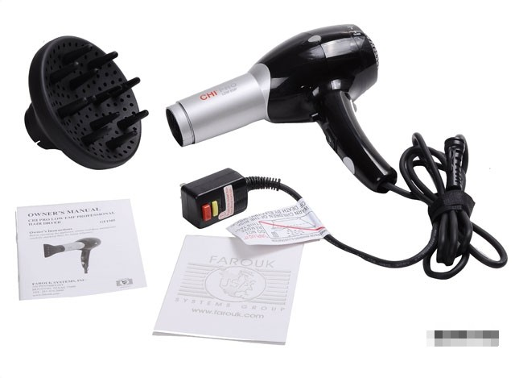 | C16 | 31usd |  | 31usd |  | 30.5usd |  | 30usd |  |  | 29.5usd |  |  | 29usd |  | N
T3 Hair Straightener 1’inch | 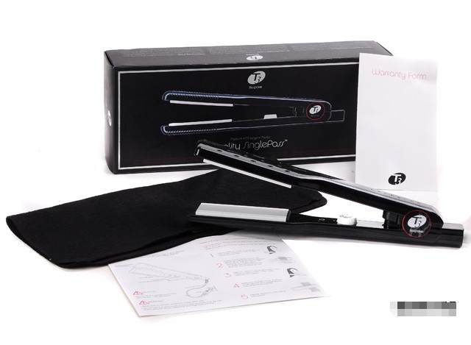 | T02 | 28usd |  | 28usd |  | 27.5usd |  | 27usd |  |  | 26.5usd |  |  | 26usd |  | N
Freight：
Other Image： | 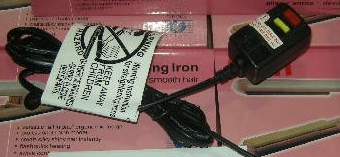with reset plug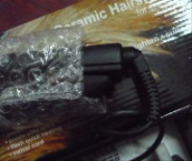cord part  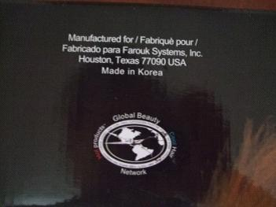original label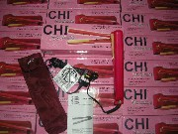bulk in stock
Terms of Payment： | T/T(bank transfer),Western Union,Moneygram,Paypal,Moneybooker |  |  |  |  | Lead Time： |  | All models in stock,ship at once when remittance arrived
Add： | NO89,Industry Zone,Jinjiang City,Fujian Province,China |  |  | Skype： |  | riverbirdtrade |  |  |  |  |  |  | Packing： |  |  | All brand new in packing
Shippment： | 3 to 5 workings by DHL or UPS |  |  | Yahoo： |  | riverbird_trade@yahoo.com.cn |  |  |  |  |  |  | Sample： |  |  | available

