 | iPhone Series (3th. Nov)
Sciphone I68+ |  |  | I9+ + /I9++/ i68+ 3G | I9 | I9-3G | I909
I68+: $52  (Quad Band) |  |  | I9+: $57  (Quad Band) | $66  (Quad Band) | $79  (Quad Band) | $72  (Quad Band)
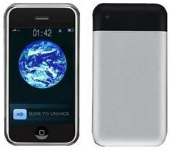 |  |  | 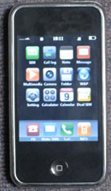 | 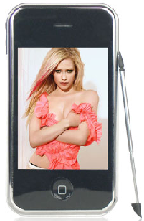 | 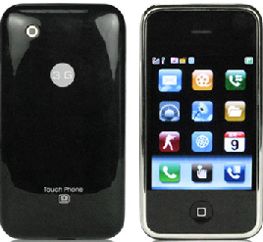 | 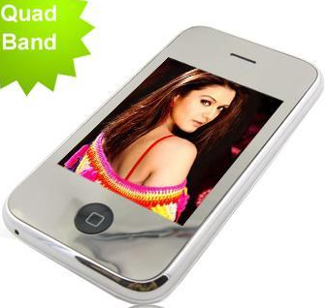
Dual GSM sim dual standby  3.2inch Touch Screen  With camera  T-Flash card supported  Bluetooth, MP3 MP4, GPRS  Hand-shake function & JAVA |  |  | Dual GSM sim dual standby  3.2inch Touch Screen  With camera  T-Flash card supported  Bluetooth, MP3 MP4, GPRS  FM Radio | Dual GSM sim dual standby  3.2inch Touch Screen  With camera & JAVA  T-Flash card supported  Bluetooth, MP3 MP4, GPRS  TV Function & FM Radio | Dual GSM sim dual standby  3.2inch Touch Screen  With camera  T-Flash card supported  Bluetooth, MP3 MP4, GPRS  TV Function & FM Radio | Dual GSM sim dual standby  2.8 inch Touch Screen  With camera & JAVA  T-Flash card supported  Bluetooth, MP3 MP4, GPRS  Black, white, red, green. blue
I9 B |  |  | I9 S | Music phone | F1/i32 | I98
$79  (Quad Band) |  |  | $79  (Quad Band) | 3.2 inch $91  $123 for 3.5inch  (Quad Band) | $64  (Tri Band) | $79  (Tri Band)
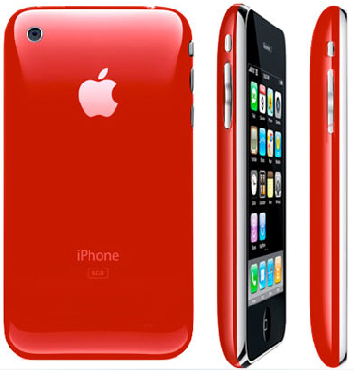 |  |  | 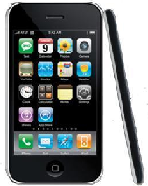 | 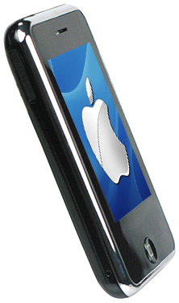 | 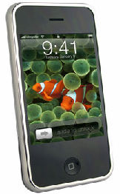 | 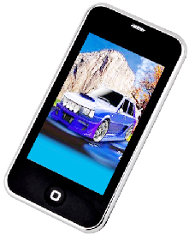
two GSM sim two standby  3.2 inch Touch Screen, Java.  Built-in Battery, Built in 4GB Flah Memory.  two camera.  Real 3G appearance. flow menu  Red, Black, white colour  (Logo is optional) |  |  | Two GSM sim two standby  3.2inch Touch Screen  Thinest phone with 10 page flow menu | 3.2/3.5 wide display screen.  Built-in Battery, Built in 4GB Flah Memory  3G style Hiphone Has applied the most updated technology  Bluetooth, MP3 MP4, GPRS | Dual GSM sim dual standby  3.2inch Touch Screen  With camera & JAVA  T-Flash card supported  Bluetooth, MP3 MP4, GPRS  & FM Radio | Dual GSM sim dual standby  3.2inch Touch Screen  With camera  1 GB storage without T–flash extension slot  Bluetooth, MP3 MP4, GPRS  TV Function & FM Radio
Mini iPhone Series
Ka08 |  | A07 |  | Ka09 | Music F210 /S2011 | Mini 2009
$52  (Quad Band) |  | $52  (Tri Band) |  | $51  Quad band | $72  (two Band) | $70  (two band)
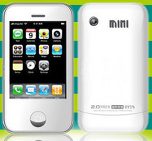 |  | 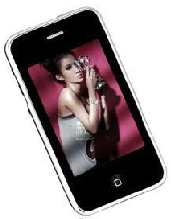 |  | 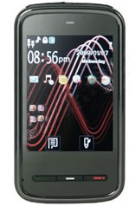 | 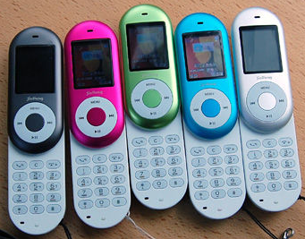 | 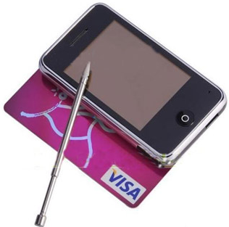
two GSM sim two standby  2.6 inch Touch Screen  With camera & FM Radio  Bluetooth, MP3 MP4, GPRS  & FM Radio  Black, white, pink, green…. |  | 2.4 inch Touch Screen  Support RM RMVB format  Camera/T-Flash card supported  Bluetooth, MP3 MP4, GPRS  & FM Radio |  | Dual GSM sim dual standby  2.6inch Touch Screen  With camera  T-Flash card supported  Bluetooth, MP3 MP4, GPRS  Disney phone iPhone disign | 1.8 inch screen  Music Mobile Phone ,Small and beautiful appearance,Touch Rotate Sty  Bluetooth, MP3 MP4, GPRS  & FM Radio | dual sim dual standby  TV free. 3G appearence  2.6 inch touch screen  T-Flash card supported  Bluetooth, MP3 MP4, GPRS
TV iphones
I9 TV |  | T1 |  | A510 | A520/A550 | A530
$80  (Quad Band) |  | $90  (Quad Band) |  | $90  (Quad Band) | $90  (Tri Band) | $82  (Quad Band)
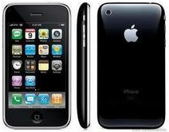 |  | 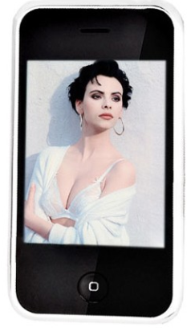 |  | 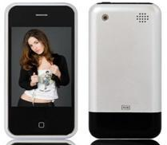 | 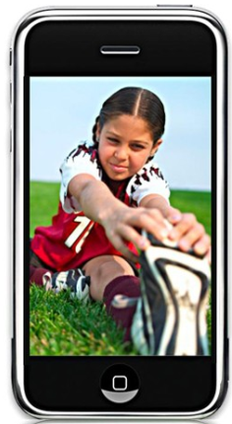 | 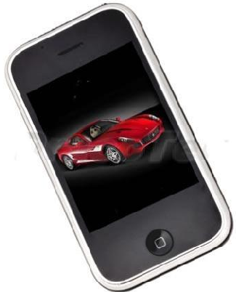
Dual GSM sim dual standby  3.2inch Touch Screen  With camera  T-Flash card supported  Bluetooth, MP3 MP4, GPRS  TV Function  FM Radio |  | Dual GSM sim dual standby  3.2inch Touch Screen  With camera  T-Flash card supported  Bluetooth, MP3 MP4, GPRS  TV Function & FM Radio  Gravity Acceleration |  | Dual GSM sim dual standby  3.2 inch Touch Screen  With camera  T-Flash card supported  Bluetooth, MP3 MP4, GPRS  TV Function  FM Radio | Dual GSM sim dual standby  3.2 inch Touch Screen  With camera, 3G appearence  T-Flash card supported  Bluetooth, MP3 MP4, GPRS  TV Function  FM Radio | Dual GSM sim dual standby  2.6inch Touch Screen  With camera  T-Flash card supported  Bluetooth, MP3 MP4, GPRS  TV Function  FM Radio
V800 |  | A560/A800 |  | N8 | A380I/T666 | F003
$92 (Quad Band) |  | $91  (Quad Band) |  | $72  (Quad Band) | $70  (Tri Band) | $116  (Quad Band)
、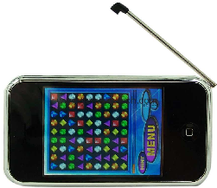 |  | 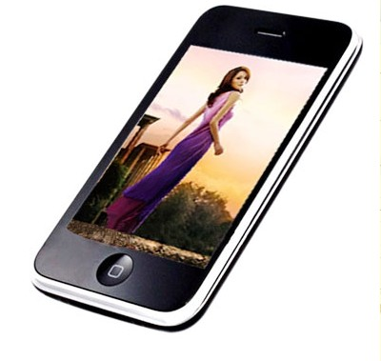 |  | 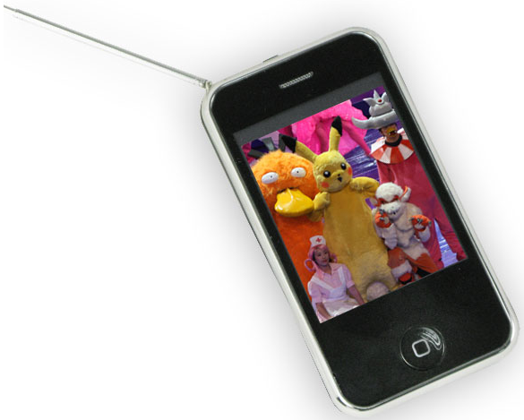 | 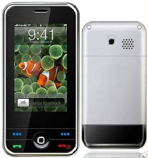 | 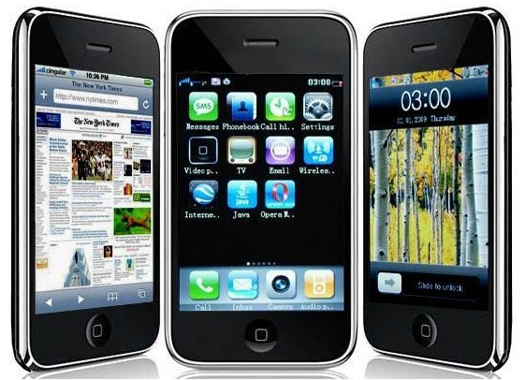
Dual GSM sim dual standby  3.2 inch Touch Screen  With camera  T-Flash card supported  Bluetooth, MP3 MP4, GPRS  TV Function  FM Radio |  | Dual GSM sim dual standby  3.2 inch TFT Screen  With dual cameras  T-Flash card supported  Bluetooth, MP3 MP4, GPRS  TV Function  FM Radio |  | dual sim dual standby  TV free.  2.6 inch touch screen  T-Flash card supported  Bluetooth, MP3 MP4, GPRS  English,French,Spanish, portugal,Italian,Turkish,Thai | Dual GSM sim dual standby  3.2 inch TFT Screen  With camera  T-Flash card supported  Bluetooth, MP3 MP4, GPRS  FM Radio | WIFI JAVA modles  dual sim dual standby  TV free.  3.2 inch touch screen  T-Flash card supported  Bluetooth, MP3 MP4, GPRS
F006 |  | F008 |  | T32 | M88 | N2
$119  (Quad Band) |  | $123  (Quad Band) |  | Out of storge  (Quad Band) | $155  (Quad Band) | $116  (Quad Band)
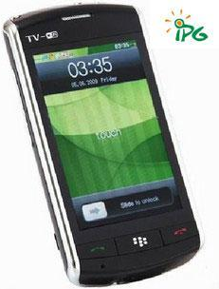 |  | 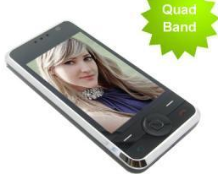 |  | 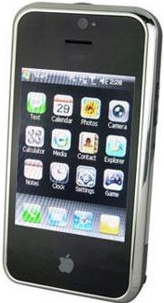 | 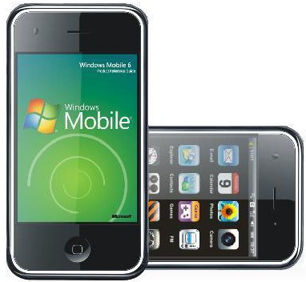 | 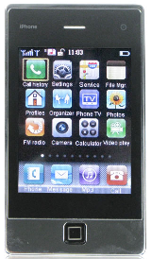
GOOGLE ANDROID F006 (BLACKBERRY 9500 appearance)/WIFI  Dual GSM sim dual standby  3.2 inch Touch Screen  With camera  T-Flash card supported  Bluetooth, MP3 MP4, GPRS  TV Function, FM Radio |  | Wifi modles  Dual GSM sim dual standby  3.2 inch Touch Screen  With camera  T-Flash card supported  Bluetooth, MP3 MP4, GPRS  TV Function  FM Radio |  | Windows Mobile 6.0 Smart Phone T32 with Wifi and GPS  3G modles  3.2 inch  With camera  T-Flash card supported  Bluetooth, MP3 MP4, GPRS , FM Radio | Windows Mobile Smart Phone T32 with Wifi 3G modles  3.2 inch  With camera  T-Flash card supported  Bluetooth, MP3 MP4, GPRS , FM Radio | HiPhone 3nd Quad band TV Phone - G-sensor Phone With WIFI ,Java and Built-in 2GB  Dual GSM sim dual standby  3.2 inch Touch Screen  With camera  T-Flash card supported  Bluetooth, MP3 MP4, GPRS  TV Function  FM Radio
Note:

1,All price is based on FOB Shenzhen and MOQ is 10pcs, and including 1G cards.
2,Warranty: 1-2 year.
3,Lead time: within 2 working days after confirm the payment.
4,Payment method: T/T in advance,order amount below $3000 USD prefer Western Union or MoneyGram.
5,Shipping method: by EMS,FedEx,UPS,DHL Express
6,If need more quantity,PLS kindly contact me,I will give you a more favorable price.

