36W Cornbulb

<1> Dimension and available socket
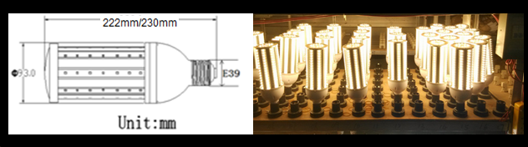
The size of the product with E39/E40 lamp holder:φ93*230mm
The size of the product with E26/E27 lamp holder:φ93*222mm
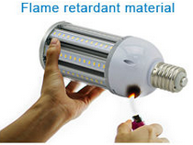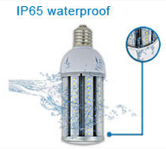

<2>Specification
Model Number | SL-Cornbulb-006D | Warranty Time | 5years
Led Source | SMD5630
Led Quantity | 117PCS
Power | 36W
Luminous | 4500lm±50lm
harmonic distortion | <12%
Color Temperature | Warm white | Pure white | Cool white
 | 2800-3200K | 4000-4500K | 6000-6500K
CRI | 80
Input Voltage | AC 100-277V 50-60 Hz
Dimmable | No
Operating Temp | -40°C～50°C
Power Factor | >0.92
Beam Angle | 360°
Lamp Base | E26 E27 | E39 E40
Material | Extruded aluminum heat sink
Lift Span | 50,000hours
Warranty | 5years
Applications | Indoor lighting
Package | White box/customized,
More packing info, also refer to the following Item No.5
Eco-Friendly
◘ Efficient design that greatly reduces energy usage
◘ RoHs compliant(Free of mercury and lead) construction
◘ Produces no ultraviolet radiation(UV)
Design
◘ Thick aluminum housing for superior heat dissipation
◘ Utilizes high luminosity SMD LED Chips
◘ Compatible with a standard E26 E27 E39 E40 socket

Operation
◘Instant turn on time(no flickering)
◘Glare free and even light distribution
◘ LED life is unaffected by frequency of use
Reliability
◘ Long operating life of over 50,000hours
◘ Lasts up to 10 times longer than filament lamps
◘ No wear and tear components unlike standard
fluorescent lighting



<3>Luminous emittance
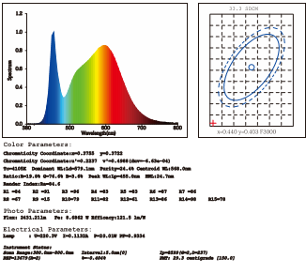
<4> How to select the starlight cornbulb ?
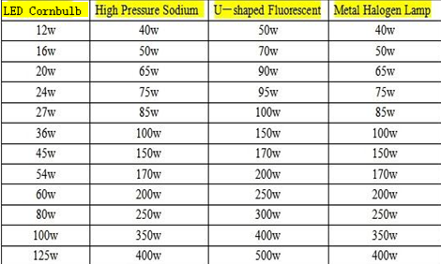

<5>. Package:
Parameter | Value | Unit | Parameter | Value | Unit
Single package size | L250*W100*H100/pc | mm | Single carton size | L480W370H380/Carton | mm
Net Weight | 0.86 | Kg/PCS | Gross Weight | 0.92 | Kg/PCS
QTY/Carton | 12 | PCS/carton | Total Weight | 11 | Kg/carton
Note: The above weight not including the weight of wooden stand.
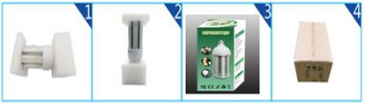

<6>. Installation project
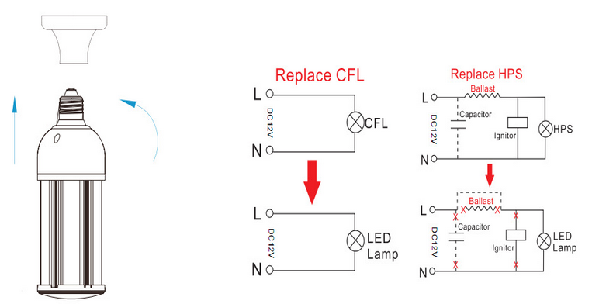
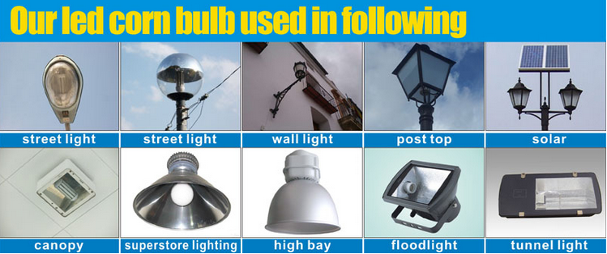

<7> Notes:
1.Before the installation, please make sure the working voltage on the installed location is consistent with the product.
2.When installing, please confirm the lamp base of the installed corn light is compatible with its lamp
holder.
3.Please turn off the power supply before installing to prevent electric shock.
4.This product does not have dimming function, please do not use dimmer.
5.This product has no waterproof function, it is forbidden to directly put it into water to use.
6.If products do not need to be used in a long time, please store them in a cool, dry and clean environment;
7.When the product emerges non-artificial damage, please do not dismantle and repair it privately, you should send it back to the original company for technical analysis and maintenance;

8.The parameters in this specification will change comply with the upgrading of products ,after changing, there is no further notice, please forgive the inconvenience.



