FEIGAO Brushless Speed controller

SPEC:
Input Voltage: 4-6 cells (1.2 Volts DC/cell), If you run 4 cells for your applications, we recommended you use an external battery for the receiver.
Rated Current: 60A
Maximum Current: 240A (10 seconds)
Sensored Brushless Motor Limit: 5.5T for 6 cell 7.2V and 4.5T for 5 cell 6.0V
BEC Voltage/Current: 5V/3A
Resistance: 1mOhm

Advantages:
1. Linear throttle and low cogging.
2. Over voltage/Over heat/Signal loss protection
3. Racing Response System – DRS
4. Programmable forward / brake and reverse modes
Installation instruction:
Connect ESC to motor, receiver and battery based on following diagrams, setup the neutral and throttle end points then the ESC is ready for use.
Please pay close attention to the positive and negative terminals of battery / A, B, C connection sequence on sensored ESC and sensored motor. 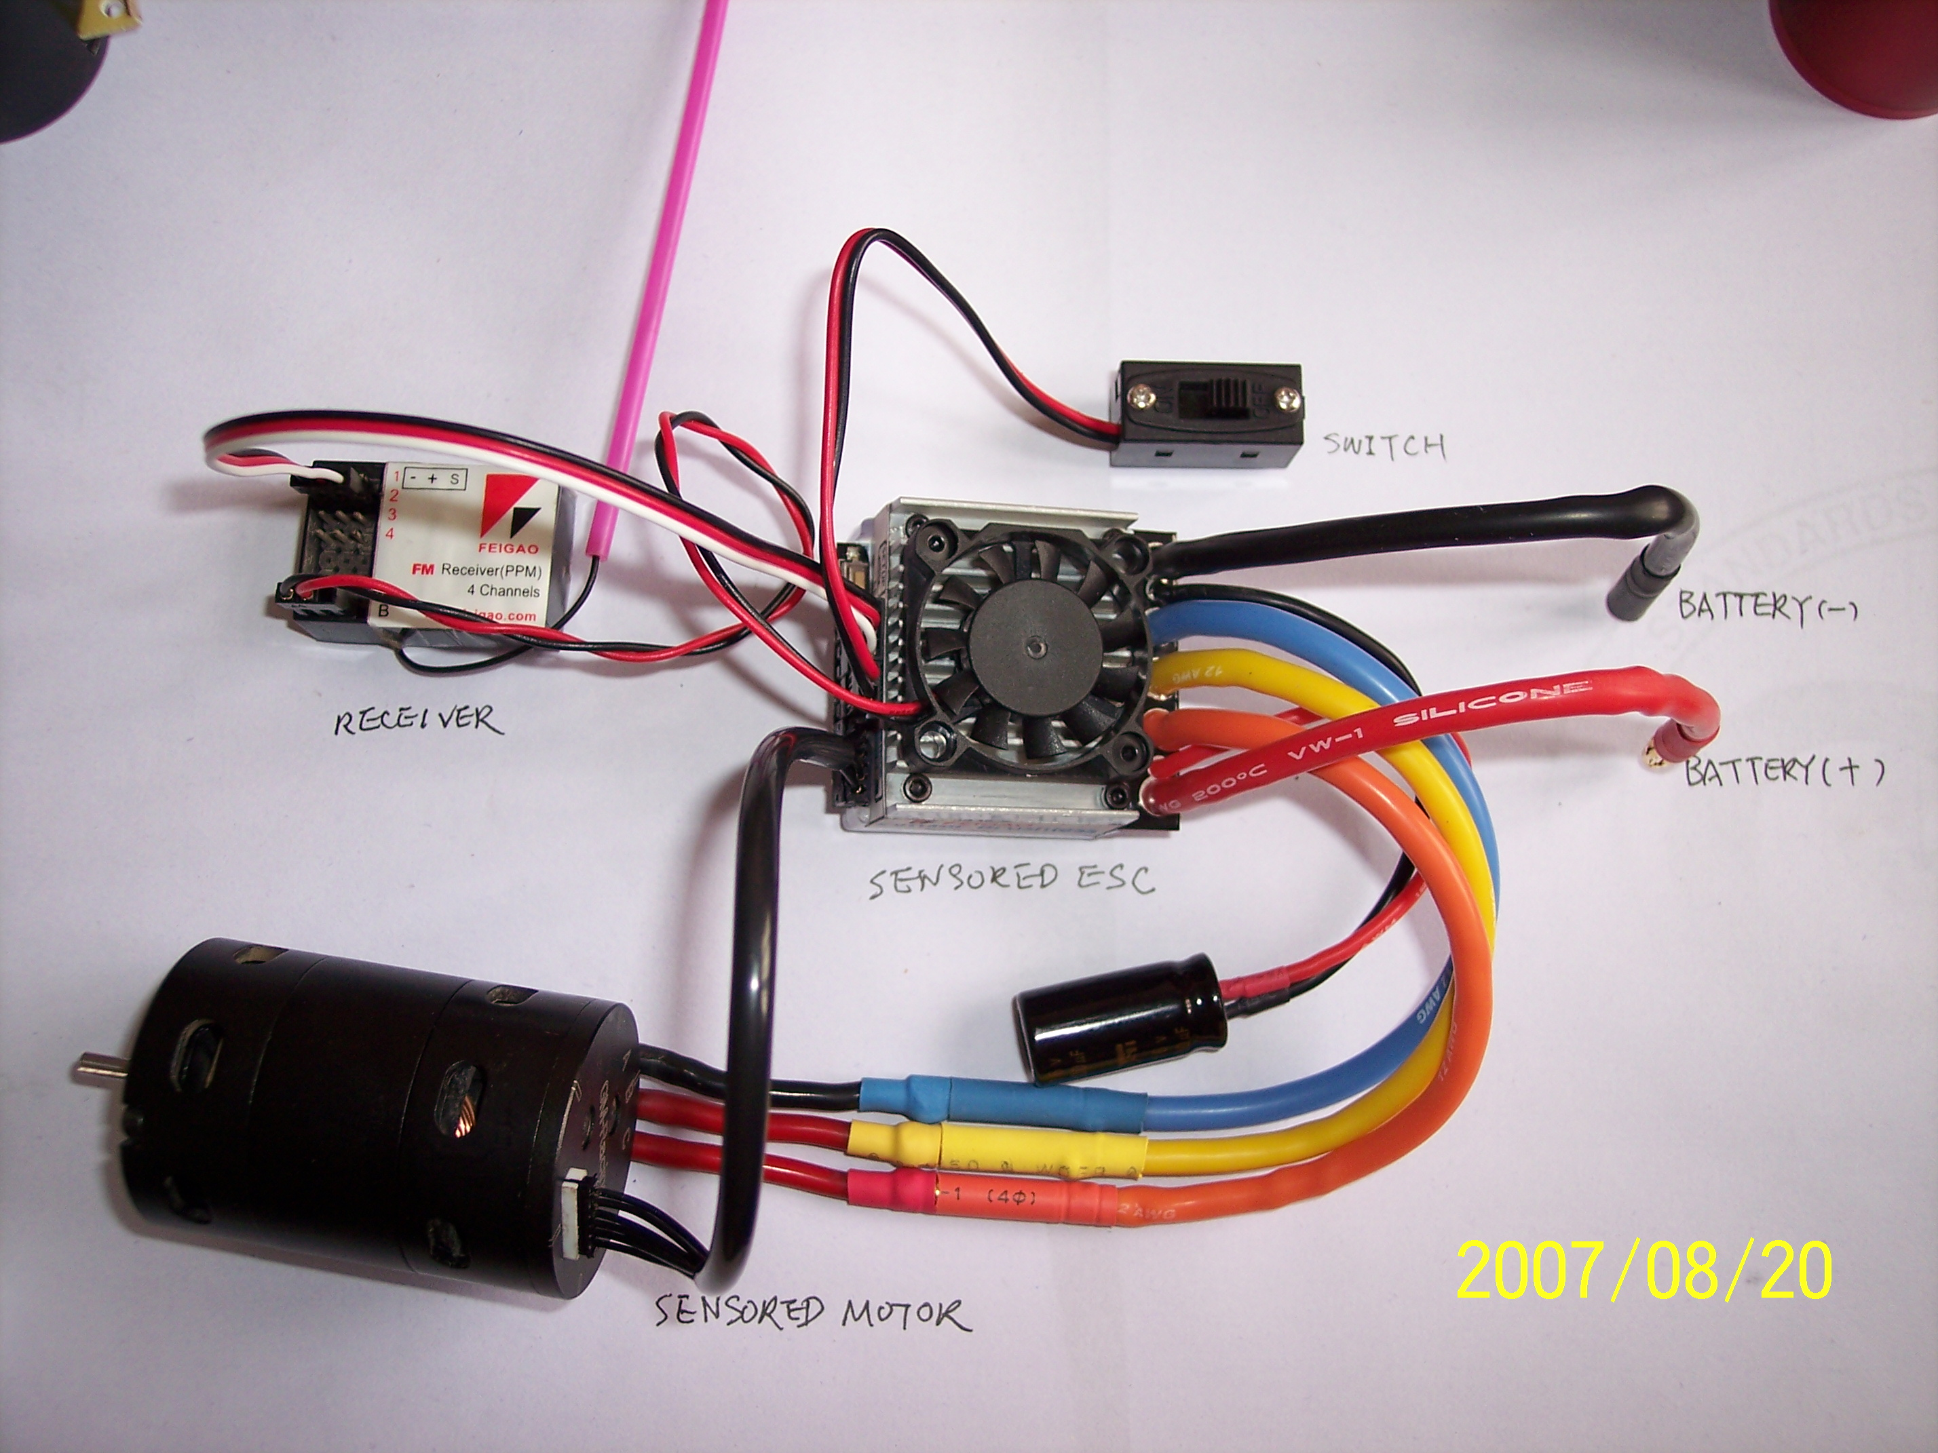
Neutral setup:
FEIGAO Sensored ESC already have default factory setup, the user only needs to setup the throttle neutral position and ESC is ready for use.（User needs to setup the neutral throttle for first time use and make sure the neutral position is right）
Throttle neutral position setup operation procedure：
Press the setup button and hold it, turn the ESC on→Release the button till the green light is off→Red and green lights will flash at the same time→Red and green lights will switch off at the same time, Now enter the neutral setup mode→move the controller to full throttle position, the green light will come ON, keep the throttle in this position for 1 second→move the controller to full brake position until the red light is ON, keep the throttle in this position for 1 second→move the throttle to the neutral position, then push the setup button once. →ESC will restart and now Setup is finished. Have fun now!!!
Remark：All other setting will remain default after this setup.
When you start to operate ESC, PULL the throttle to maximum position (forward direction), the green light on the ESC will be solid; MOVE the throttle to full (brake/reverse direction), the red light on ESC will be solid.
Restore default setup：Press the setup button and hold it. Turn on the power of ESC and wait for about 6 seconds, until the red light flashes. Now release the button and default spec on ESC will restore successfully!!!

Basic function setup:
Tips: Please notice that in ESC program，EXIT menu/sub-menu and MOVE to next menu or CONFIRM the selected parameter are just wait for 2 seconds.
- How to enter setup menu：Make sure that you’ve connected the motors and ESC correctly before you power up the ESC.
Power up ESC→ Press setup button and hold it for 2 seconds at anytime after the ESC is powered up →Red light and green light will flash once, then the green light will be solid on.→Release the button and now you have entered the setup menu successfully:

After enter the menu

Push setup button and release
Red light double flash once
Enter motor setup mode submenu, see table 1.1

No operation After finishing selection, wait for 2 seconds, ESC will exit
After 2 seconds Submenu and return to upper menu

Push setup button and release
Red light double flash twice

Enter Battery voltage protection and battery voltage test submenu, see table 1.2

No operation After finish selection, wait for 2 seconds, ESC will exit
After 2 seconds Submenu and return to upper menu

Push setup button and release
Red light double flash three times

ESC temperature protection, battery protection selection submenu, see table 1.3

No operation After finish selection, wait for 2 seconds, ESC will exit
After 2 seconds Submenu and return to upper menu
ESC restart

How to choose the right settings for you: When you enter each sub-menu, you can read current parameters by the different light combinations, for detailed information please see each data table. Within 2 seconds, you can change parameters by pressing the setup button, based on the light combinations in each data table. If there is no operation after 2 seconds, then the ESC will save current data and exit to next main menu. (Same process for all setups)

Table 1.1 Motor mode （selection：after entering this table, press the setup button to switch the parameters based on this table. After choose the desired parameter, wait for the ESC to exit this submenu (no operation for 2 seconds). ESC will move to next setting if there ions operation after 2 seconds.
Green LED | Red LED | Function
OFF | OFF | Dual direction brake mode1——reverse with 25% power based on throttle operation（ESC default setting）
OFF | ON | Dual direction brake mode2—— reverse with 100% power based on throttle operation
ON | OFF | Single direction brake mode
ON | ON | No brake mode for both direction

Table 1.2 Battery voltage protection and battery voltage test （You must enter this setting if you change different voltage battery packs, default voltage is 6 cells NI-HM）
Green LED | Red LED | Function
OFF | ON | Protection voltage is 0.8V/cell
ON | OFF | Protection voltage is 1.0V/cell（Default）

Table 1.3 ESC temperature protection, battery protection selection
Green LED | Red LED | Function
OFF | OFF | ESC reduce output power when temperature or voltage protection functions activates（Default）
OFF | ON | Temperature protection activated: ESC will stop output. Battery voltage protection activated: ESC will reduce output
ON | OFF | Temperature protection activated: ESC will reduce output Battery voltage protection activated: ESC will stop output.
ON | ON | ESC no output when either temperature or voltage protection function is activated

Advanced Setting:
- How to enter：Press the setup button and hold it→Switch on the ESC→Green light will be off (Keep setup button pressed)→ After 4 seconds, the green light will be ON and the red light will be OFF→Release the button and enter the advanced setting menu.

After enter menu

Push setup button and release
Red light double flash once

Enter “DRS” setting Enter this submenu, see table 2.1

No operation After selection is finished, wait for 2 seconds, ESC will After 2 seconds Exit submenu and return to upper menu

Push setup button and release
Red light double flash twice

Enter ABS “Drag” brake setting submenu, see table 2.2

No operation After selection is finished, wait for 2 seconds, ESC will
After 2 seconds Exit submenu and return to upper menu

ESC restart

Table 2.1 Racing Response System – “DRS” setting
Green LED | Red LED | Function
OFF | ON | Smooth (Default）
ON | OFF | Normal Frequency
ON | ON | Aggressive Frequency

Table 2.2 ABS “Drag” brake setting
Green LED | Red LED | Function
OFF | OFF | Neutral brake→None（Default）
OFF | ON | Neutral brake→Low
ON | OFF | Neutral brake→Middle
ON | ON | Neutral brake→High

Exemption Clause:
FEIGAO do not have control over the installation or use of this product therefore no liability for any damages incurred in its use will be accepted. Operation of this product is at the user’s risk. The use of R/C models requires a degree of skill,
If you are a beginner please consult the advice of an experienced user to prevent injury to goods or other persons.

Caution:
  - Do not operate the ESC at voltages lower than 4.8V or higher the 8.4V battery, damage to the ESC can result.
  - For efficient operation for the ESC is keep the motor and battery wires as short as possible (do not exceed 20cm)
  - When mounting the brushless motor in your car, pay careful attention to the length of the motor screws, they must not exceed 4.0mm in depth, longer than this and internal damage to the motor will result, which will void the product warranty.
  - Ensure all connections are secure before using this product.
  - FEIGAO reserve the right to modify the design, appearance and specification of the product without notice.

Warranty period:
1 year free labor “Not include parts”
2 months return time for any repair or services
3 months limited warranty period.

1-2-3 service ensure you’ll enjoy your R/C models with FEIGAO

